Upstream job

pipeline {

agent any

stages {

stage('Install Ansible') {

steps {

echo "Job2: Installing Ansible..."

sh '''

sudo apt-get update

sudo apt-get -y install ansible

'''

}

}

}

}

Downstream job

In downstream job:

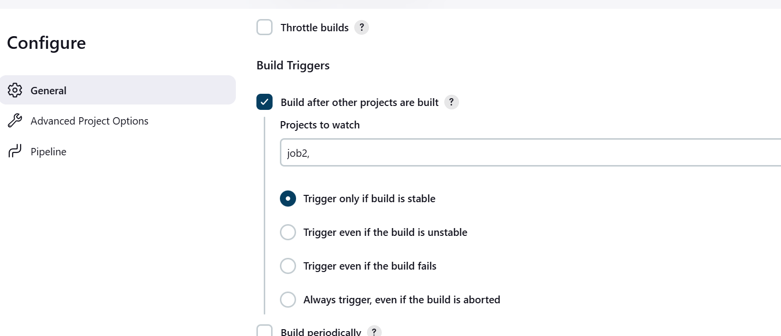

pipeline {

agent any

environment {

REPO_URL = 'https://github.com/amitopenwriteup/tfsource.git'

BRANCH = 'main'

}

stages {

stage('Checkout Repository') {

steps {

echo "Checking out repository from ${REPO_URL} (branch: ${BRANCH})"

git branch: "${BRANCH}", url: "${REPO_URL}"

}

}

stage('Run Ansible Playbook') {

steps {

echo "Running Ansible Playbook from ${REPO_URL} (branch: ${BRANCH})"

sh '''

# Ensure the repo is already cloned in the workspace

ansible-playbook -i inventory playbook.yaml

'''

}

}

}

}